Week 3 Day 3 17/5/23

# Arrays

* An array is a data structure which can hold more than one value at a time in an ordered fashion like a list of items.
* Used to store multiple values in a single string.



# Exercise 1

1. Create an array of your favourite food.
2. Log the array to the console.

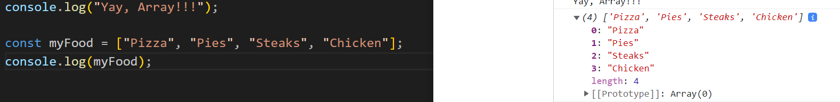

# Access the Elements (values) of an Array.

* JavaScript arrays are zero-based indexed.
  + The first element of an array starts at index 0, the second element starts at index 1 and so on.

To access an element in an array, you specify an index in the square brackets[].

To change the value of an element, you assign that new value to the element.

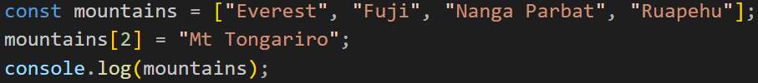

# Array properties

The length property of an array returns the length of an array (the number of array elements).

# Exercise 2

1. Create an array of numbers, say 1 to 15
2. Find the average of the numbers.
   1. Average=Total Sum of All Numbers/Number of Item in the Set
3. Log the average to the console
4. Share your solution + output when done!

# JavaScript Array push() Method

* If you want to add a new value/elements in to your array you can use the.pushy() method.

Now the food array becomes:



# Array of other data types

# Exercise 9

1. Create an object to hold information on your favourite recipe. It should have properties for a
   1. Title (a string),
   2. Servings (a number),
   3. And ingredients (an array of strings).
2. Console log the object and the number of the ingredients in the recipe.
3. Add an extra ingredient ‘water’ to your recipe. Hint: use array.push()
4. Log the object to the console.

